Travel & Accommodation Information for the British Down Syndrome Swimming Championships

Venue: K2 Crawley Recreation Centre 01293 585300
Pease Pottage Hill
Crawley
RH11 9BQ
Website: https://www.everyoneactive.com/centre/k2-crawley/

Date: Saturday 19th – Sunday 20th November 2022

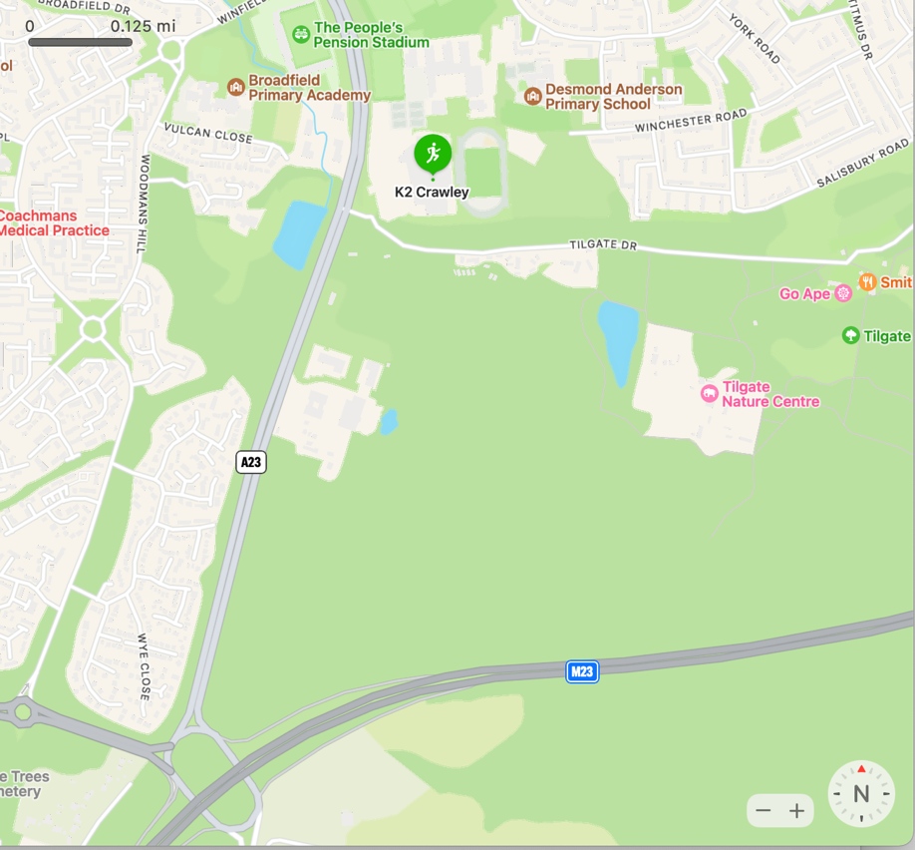

What 3 Words: happy.pies.quiz

The following information is provided only as guidance and the suggestions are not recommendations or endorsements by DSS-GB or BDSSC.

Directions: The K2 Leisure Centre is on the A23 at Pease Pottage Hill in Tilgate, between Thomas Bennett School and Tilgate Forest Recreation Centre and opposite Broadfield Stadium.

Arriving by Bus or Train
The K2 Leisure Centre is about 1.4 miles from Crawley Railway Station (services to London Victoria, Gatwick Airport and Thameslink). To walk to the leisure centre, turn right out of the station, then right again at the traffic lights onto Southgate Avenue. At the end of Southgate Avenue, turn left. The leisure centre is about 200 yards ahead of you on the left-hand side of the A23.

The number 2 bus (https://www.metrobus.co.uk/services) stops at Crawley bus station near Crawley railway station and visits the K2 Leisure Centre approximately every 15 minutes.
The number 10 Fastway bus from Gatwick airport via Crawley bus station (near Crawley Railway station) stops nearby at Broadfield Stadium and on Southgate Avenue (https://www.metrobus.co.uk/services/MB/10#timetable ).

Arriving by Car
From the south, follow the A23 towards Crawley. About one mile past Pease Pottage, get in the outside lane and turn right at the traffic lights. Watch out for the 50 mph limit as you approach the lights — there are sometimes speed traps.
From the north, follow the A23 through Crawley. Look for a roundabout containing a giant football, outside Bradfield Stadium. Go straight on in the left-hand lane, and very soon you will see the K2 Leisure Centre to your left as you approach a set of traffic lights.
From the M23, leave the motorway at junction 11, Pease Pottage. Get in the right-hand lane on the slip road, follow the roundabout all the way round and join the A23 heading towards Crawley. The K2 Leisure Centre is a little over one mile along on your right, at the first set of traffic lights.
Free car parking, including disabled bays close to the main entrance is available. Other locations nearby are often used as overflow car parks and will be signposted when in use.

Arriving by Plane
Gatwick Airport is approximately a 15 minute drive from K2. There are many car hire companies operating at the airport.

Taxis
Being so close to Gatwick Airport, Crawley has numerous taxi firms. Here is the link to the yellow pages taxi page for Crawley https://www.yell.com/s/taxis+and+private+hire+vehicles-crawley-west+sussex.html

Hotels
There are many nearby hotels. These are just a few:

The Crowne Plaza, Gatwick
The Crowne Plaza hotel have kindly offered a limited number of rooms with 15% off their best available rate for the Championships, and includes breakfast, wifi and parking. Check terms & conditions before booking.

https://www.crowneplaza.com/redirect?path=hd&brandCode=CP&localeCode=en&regionCode=925&hotelCode=LGWUK&_PMID=99801505&GPC=DSS&cn=no&viewfullsite=true

Arora Hotel
https://gatwick.arorahotels.com/

Premier Inn
Crawley Town (Goff’s Park) is 1.4 miles from K2 but there are 7 Premier Inns within 8 miles of K2
https://www.premierinn.com/gb/en/hotels/england/west-sussex/crawley.html

Travelodge
There are 4 Travelodges within 8 miles, the closest being Travelodge Crawley
https://www.travelodge.co.uk/hotels/583/Crawley-hotel?sb=1

Holiday Inn Express
https://www.ihg.com/holidayinnexpress/hotels/gb/en/crawley/cryuk/hoteldetail

Cottesmore Golf & Country Club
https://www.cottesmoregolf.co.uk/ and also self catering lodges
https://www.cottesmoregolf.co.uk/self-catering-lodges/

AirBnB
https://www.airbnb.co.uk/

Exploring Crawley:
https://www.experiencewestsussex.com/map/crawley-gatwick/

